**22 December 2020**

**VPC Peering**

**What is VPC Peering?**   
A VPC peering connection is a networking connection between two VPCs that enables you to route traffic between them using private IPv4 addresses or IPv6 addresses. Instances in either VPC can communicate with each other as if they are within the same network. You can create a VPC peering connection between your own VPCs, or with a VPC in another AWS account

**VPC Peering follows the two steps:**• Create two VPC in different region   
• Create three instances (one should public and another two-instance private)   
• Now the two private instances should share the data or between the two private subnets.

**Stage 1- VPC – Virtual Private Cloud - VPC created in Linux Machine.**  
 Steps to be followed  
 • Create VPC   
• Create subnets 1.Public subnet , 2. Private subnet   
• Create IGW(Internet Gate Way) and attached it with **VPC**  
• Create Route table 1.Public RT –Associate with 1. Public Subnet  
 Routing Associate with IGW(Internet Gate Way)  
 2.Private RT- Associate with 2. Private Subnet

• Create Security groups : 1.Public SG – RDP (3389),SSH(22),HTTP(80),HTTPS(443)  
 2. Private SG –Associate Public SG

• Create EC2 Instances / Machines 1.Public –Using our own VPC , & 1.Public SG  
 Auto Assign Public IP - Enabled 2. Private- Using our own VPC, & 2.Private SG Auto Assign Public IP – Disabled

• SSH (Secure Shell Hosting) – Login 1.Public EC2 🡪Check Connectivity  
 🡪Check Internet

Login 2.Private EC2 🡪Login from Ec1 instance  
 🡪Check Connectivity  
 🡪Check Internet

• Create NAT Gateway & Elastic IP

• Repeat Step **8** and Check Internet Connectivity

• **Stage 2-Create Peering VPC**

• Create security groups

• Create instance  
**VPC** In services under networking and content delivery VPC

**# Create VPC-1 (Here we using VPCNew)  
 CIDR - 10.0.0.0/16 (65536 ips)**

**Subnets :**Public – 10.0.1.0/24 – Public zone (256 ips)  
 Private – 10.0.2.0/24 – Private zone (256 ips)

----------------------------------------------------------------------------------------------------------------

1. **Create Your own VPC with Public & Private Ec2 instance**
2. **Prepare the Private instance will login through Public.**
3. **Ensure both Private & Public instance have access the Internet**
4. **Create VPC -2 with Private Ec2 instance alone. No public instance need.**

**# Create VPC-2 (**for VPC peering connection). **(Here we using VPC Peer)**

**CIDR - 178.0.0.0/16 (65536 ips)**

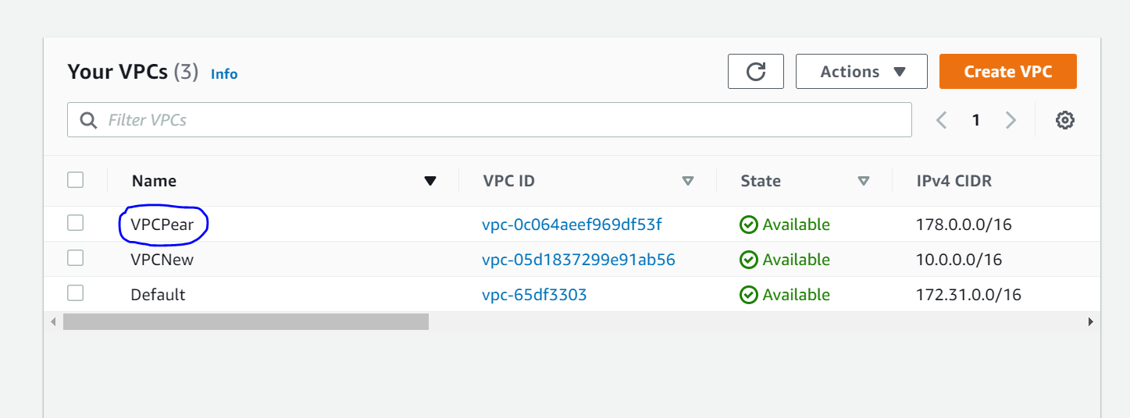

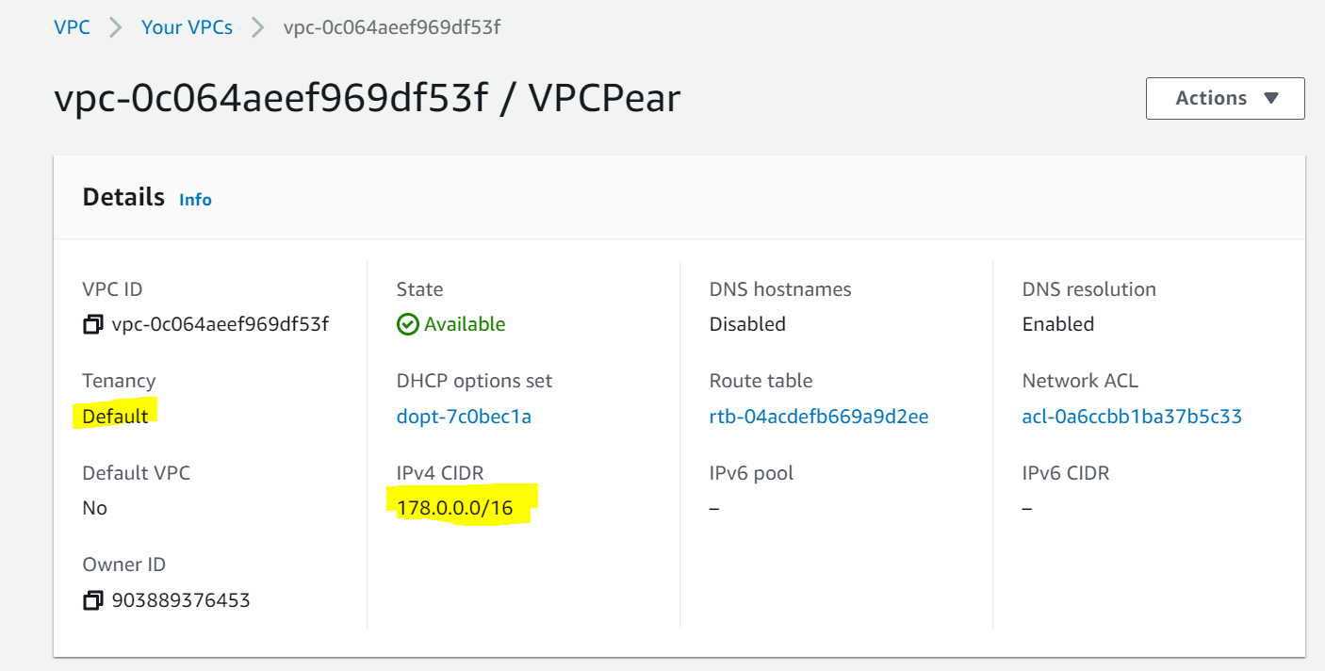

1. **Subnets :**Public – 178.0.1.0/24 – Public zone (256 ips)  
    Private – 178.0.2.0/24 – Private zone (256 ips)

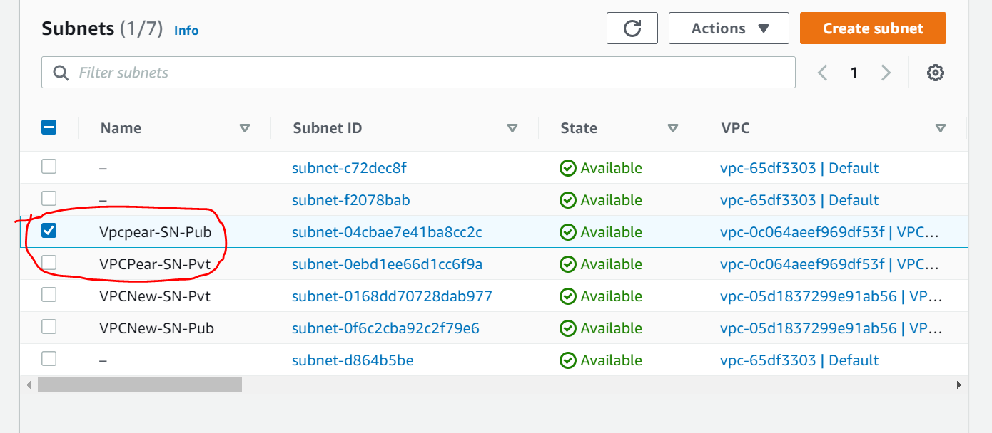

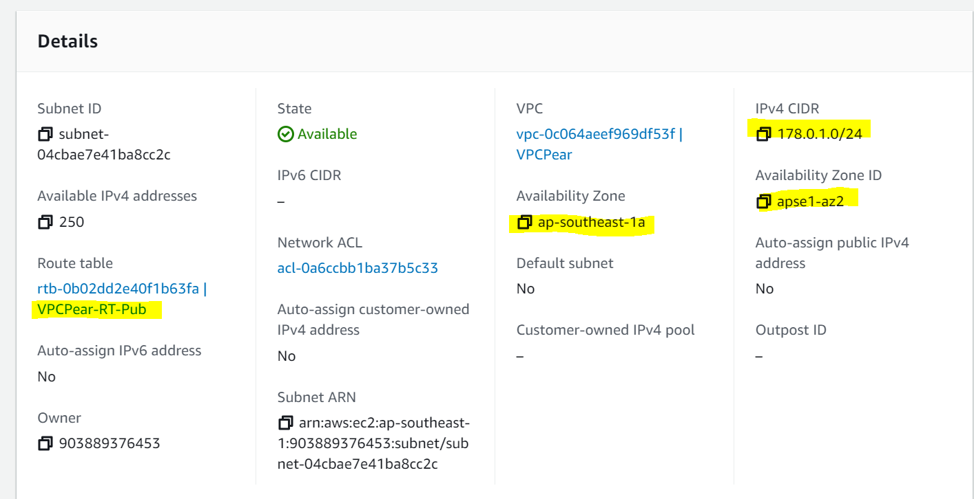

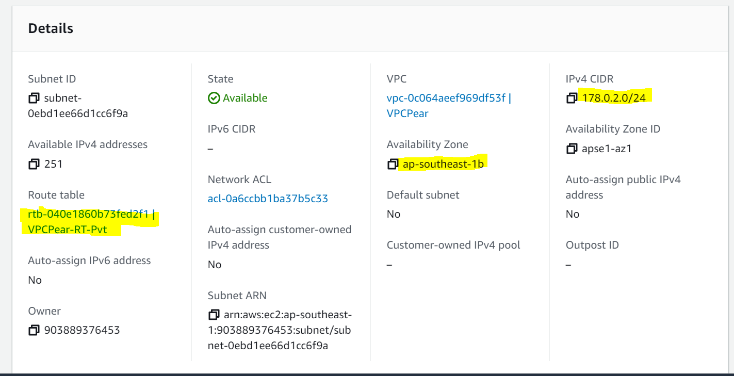

1. Internet Gateway

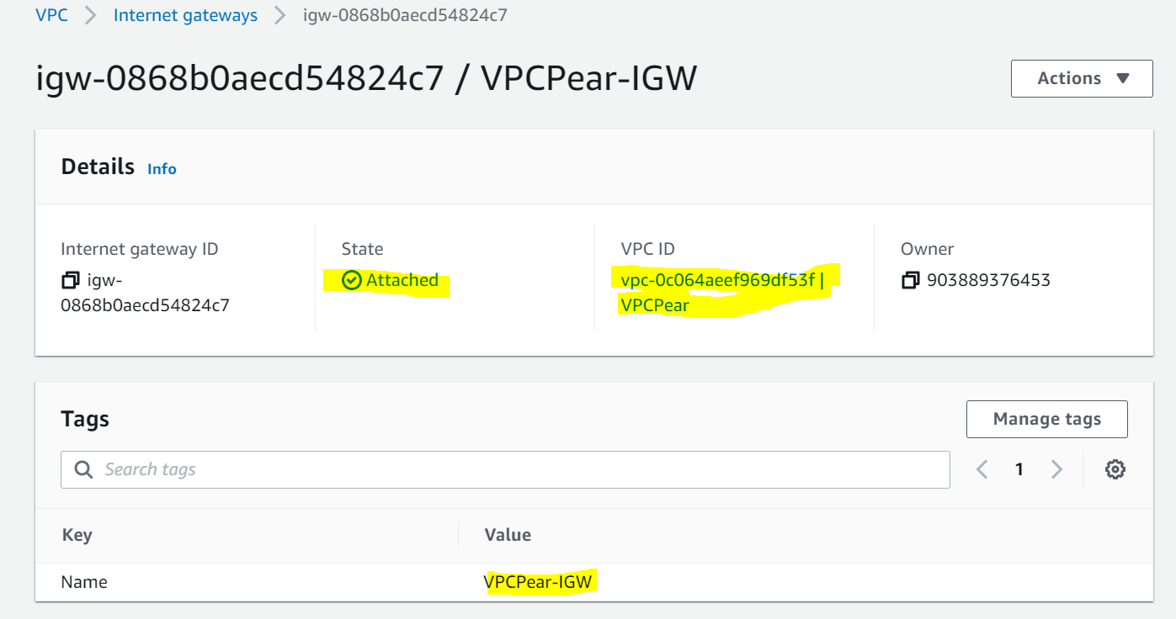

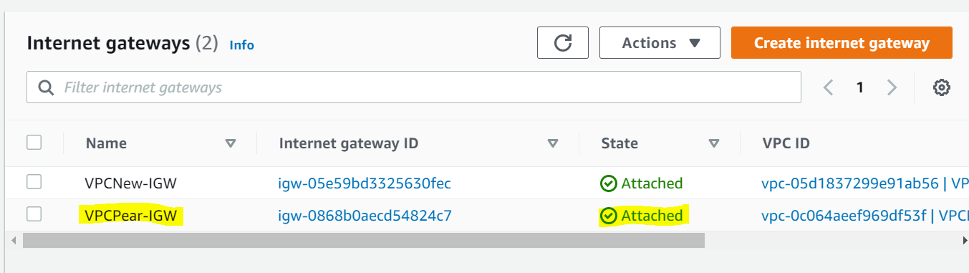

1. Routing Tables

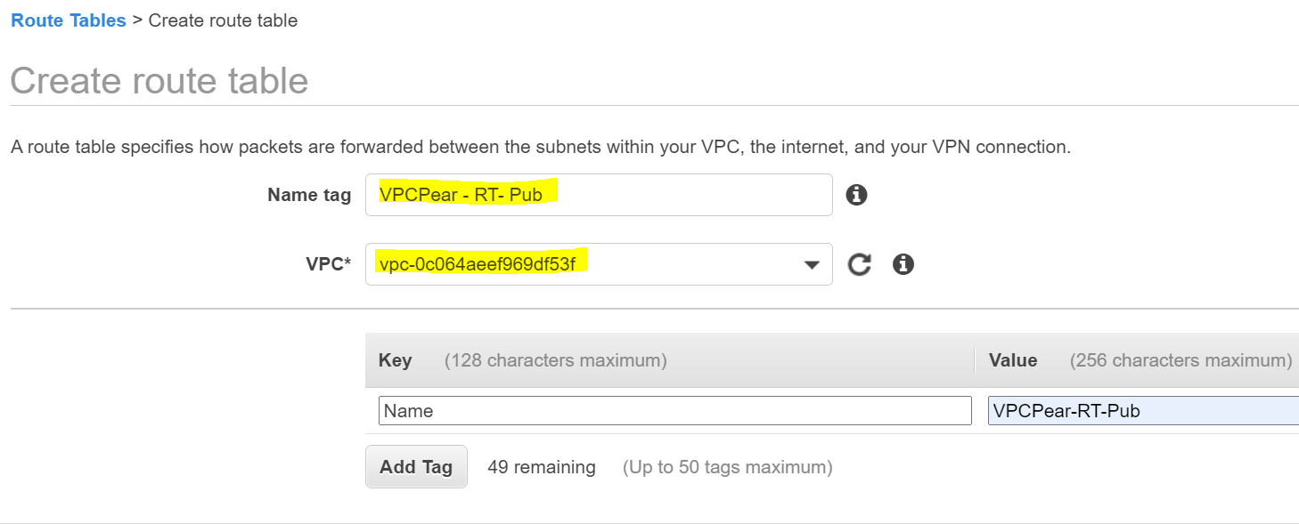

4.1 Routing Table & Subnet Associations

Select Routing Tables and associate with Appropriate Subnet.

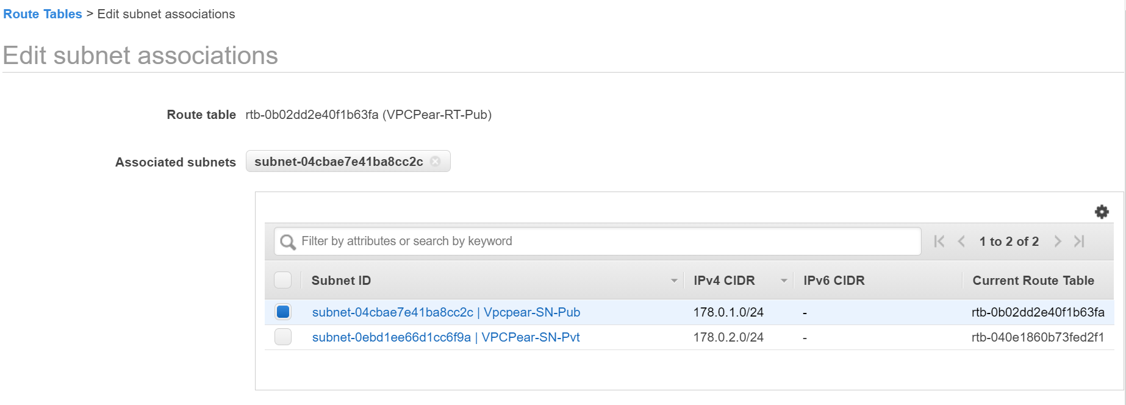

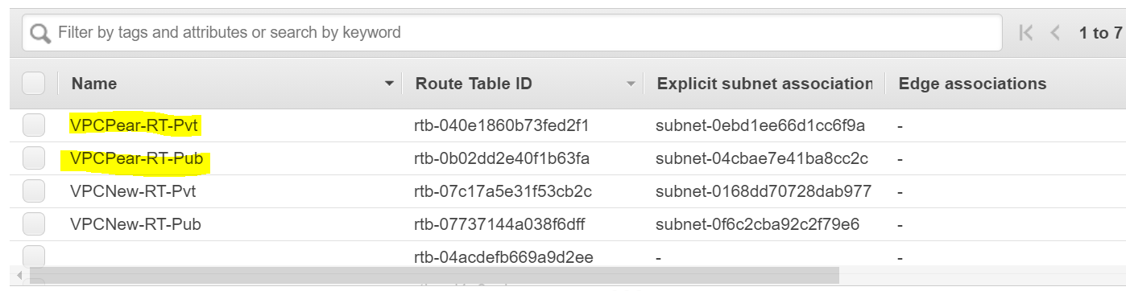

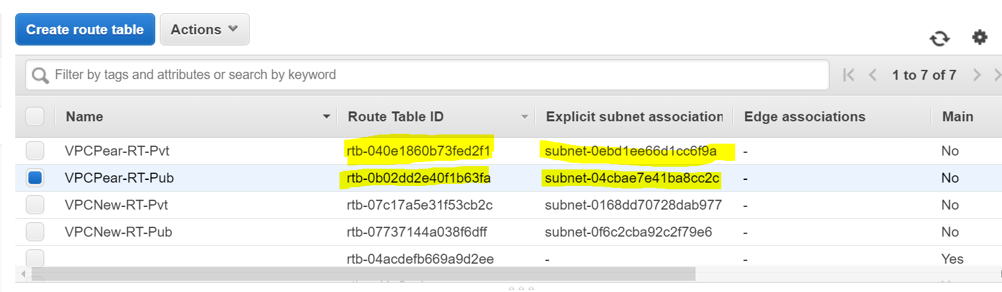

4.2 Router Associations

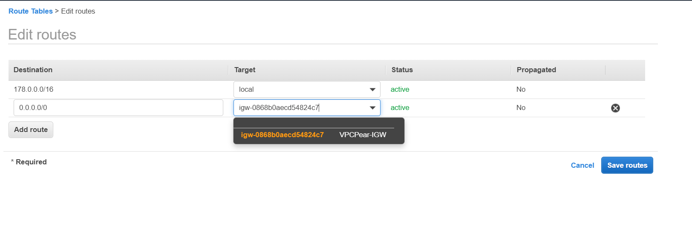

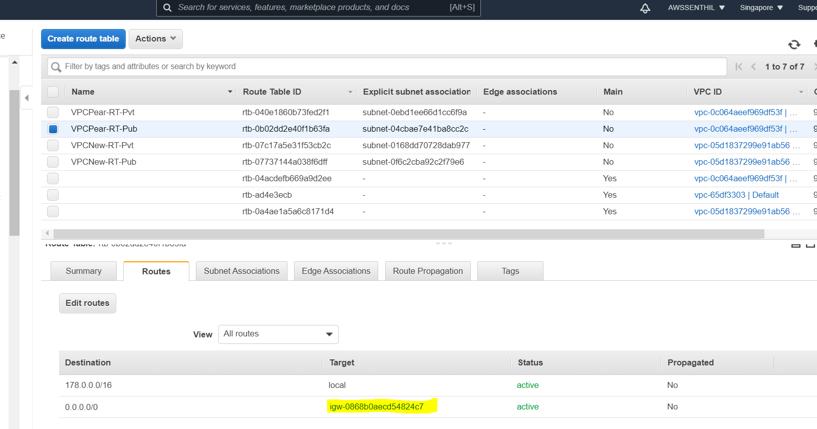

1. Create Nat Gateway

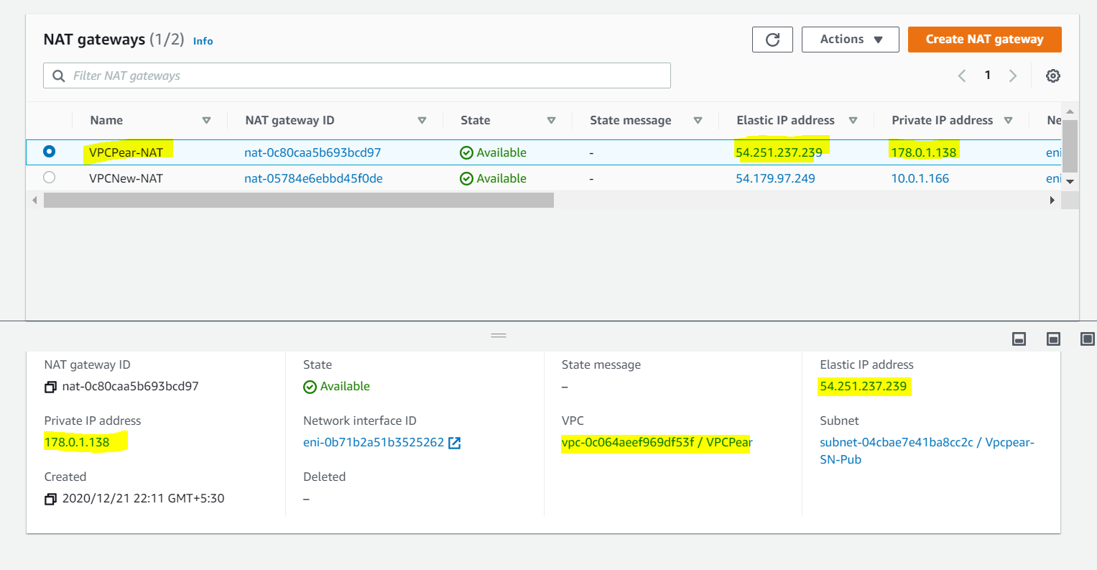

5.1 Elastic IP

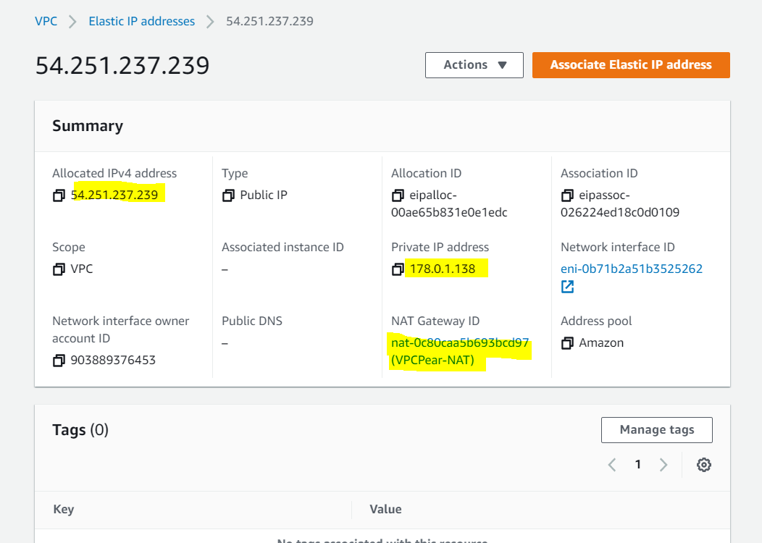

5.2 NAT- Assign to RT-Pvt

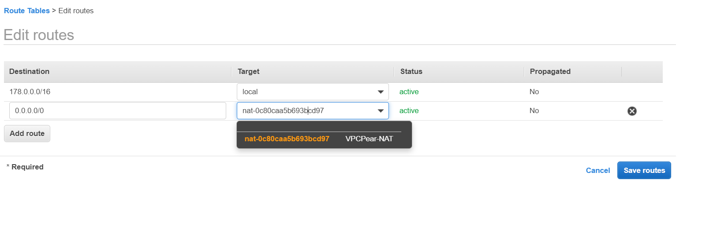

1. VPC – Peering Creation

VPC-Requester :VPC-1 – CIDR 10.0.0.0/16

VPC-Accepter : VPC-2 - CIDR 178.0.0.0/16

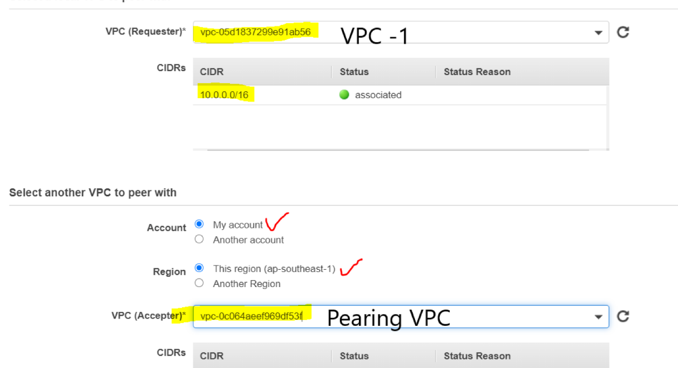

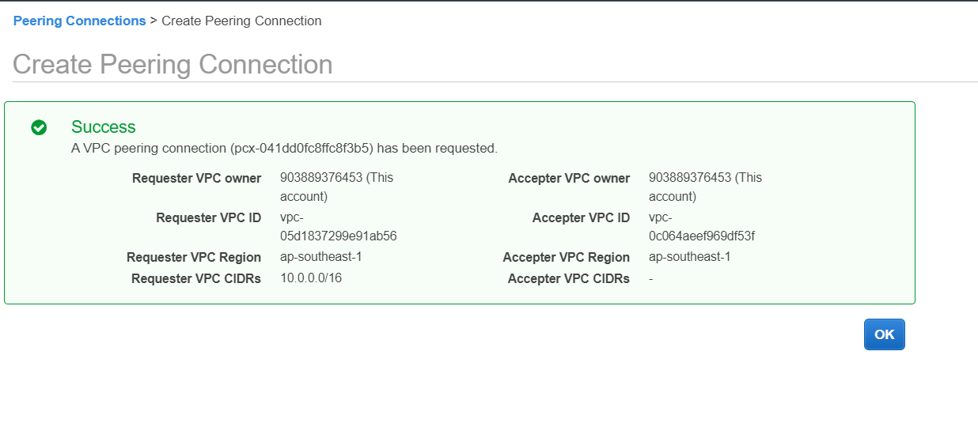

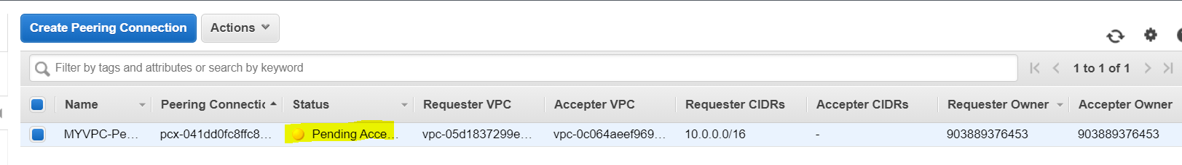

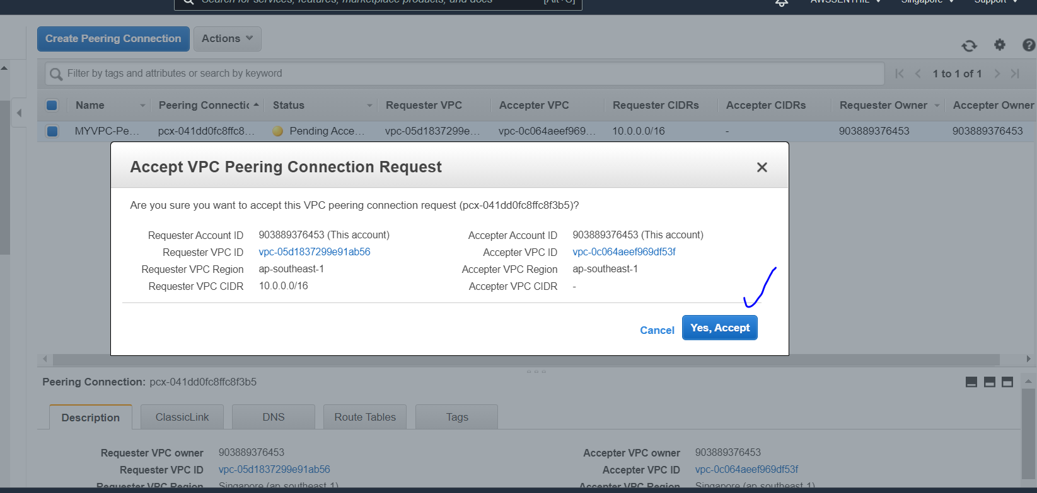

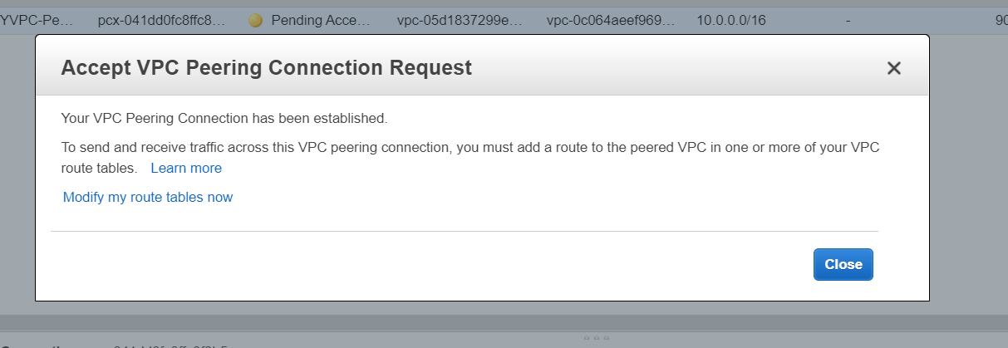

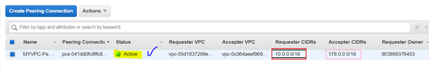

7.Edit VPC New-RT-Pvt – Routing Table ->Edit Routes

* Add Accepter CIDR Address / VPC Pearing / VPC-2 ‘s CIDR (178.0.0.0./1)  
  to VPC-1/ VPC New’s Private Routing Table
* Associate VPC Peering address in Target

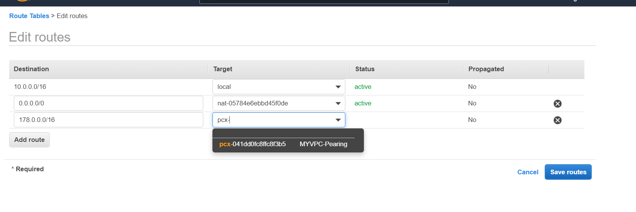

7.1 Edit VPC Pearing RT-Pvt – Routing Table ->Edit Routes

* Add VPC-1/ VPC New’s Subnet Address (10.0.0.0/16)  
  to VPC-2/ VPC Peering’s Private Routing Table
* Associate VPC Peering address in Target

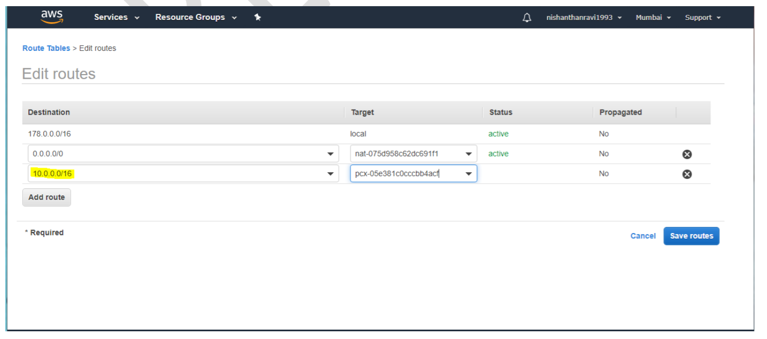

8.Create VPC_Peering EC2- Instance – Private Only

Network 🡪 VPC Peer  
Subnet 🡪 VPC Peer-SN-Pvt  
Auto Assign Public IP 🡪 Disable

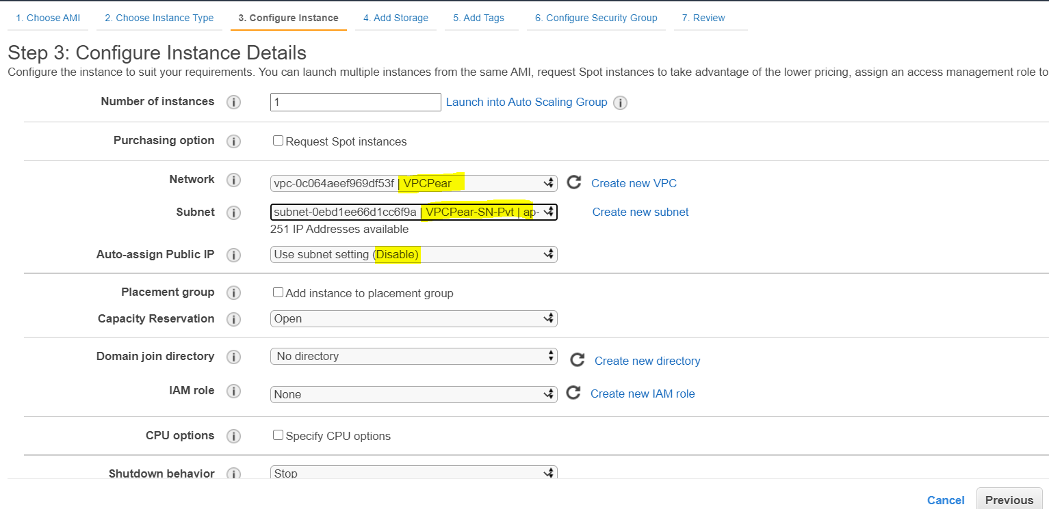

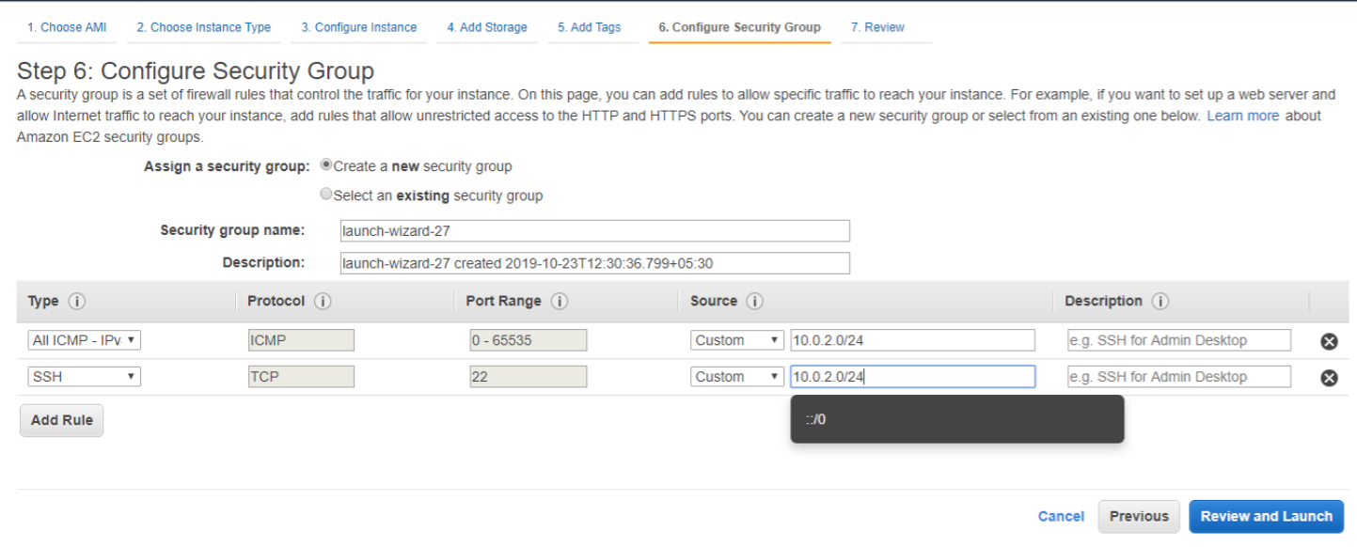

9. VPC_Peering EC2- Instance Execution – Using Putty / SSH Executor

- VPC_Peering EC2- Instance login through VPC-1. Public Machine/Ec2 Instance.

- VPC_Peering EC2- Instance – Private IP is used to Connect the EC2 Instance using SSH.

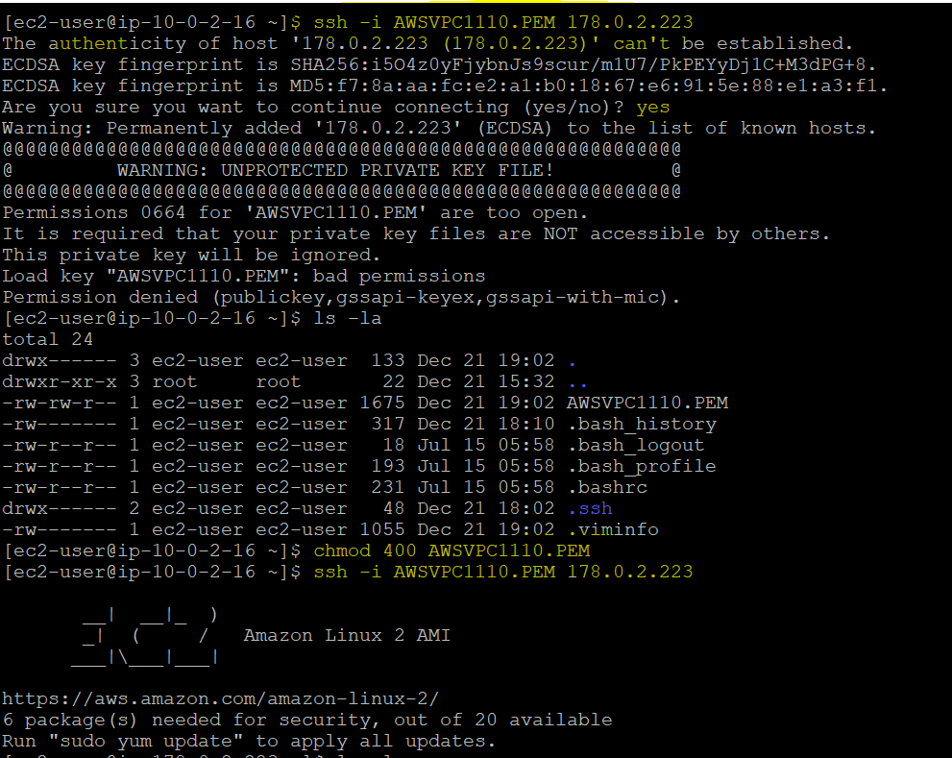

**Login Succeed**

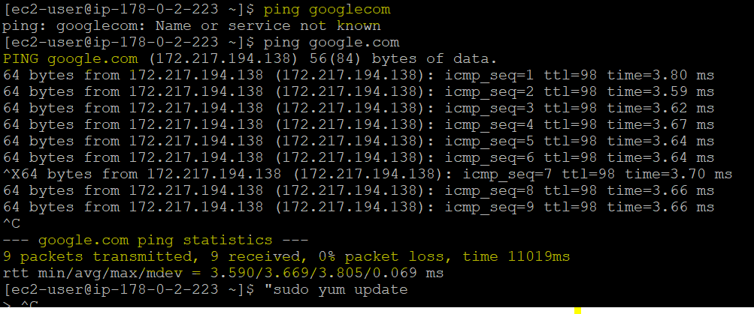

**Internet Connectivity Succeed**

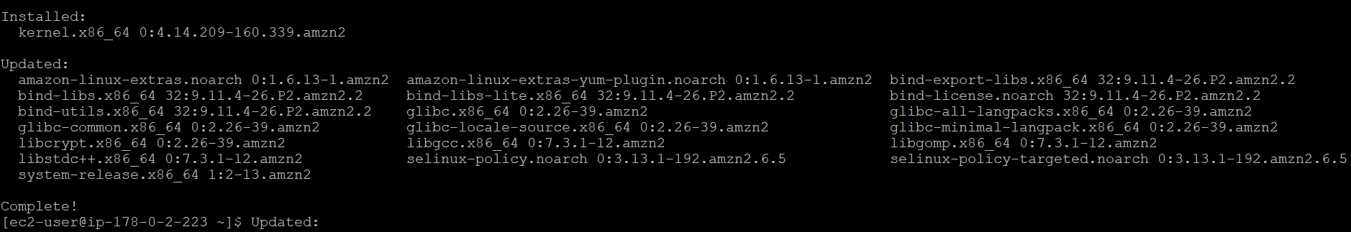**Updates Succeed**

